OUTCOME BUDGET
2012-13

MINISTRY OF CULTURE

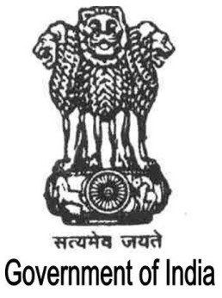
GOVERNMENT OF INDIA
Contents

Executive Summary | i-ii
Chapter I | 1-14
Chapter II | 15 - 140
Chapter III | 141- 147
Chapter IV-A | 148 - 260
Chapter IV-B | 261 – 389
Chapter V | 390 - 401
Chapter VI | 402 - 421

